# Technical Essay on Data Processing and Visualization Framework

## Introduction

In the realm of data science, the ability to efficiently process, analyze, and visualize data is crucial. This essay examines a Python-based framework designed for processing training data, ideal functions, and test data, as well as for visualizing the results. The framework consists of two main components: the DataProcessor and DataVisualizer, with a focus on modularity, maintainability, and ease of use. This structured approach facilitates robust data analysis and visualization, thereby providing valuable insights into the underlying data patterns.

## Framework Overview

The framework is built upon three core principles: **data handling**, **database integration**, and **data visualization**. Below is a breakdown of its essential components.

### DataProcessor

The DataProcessor class serves as the backbone of the framework. It manages the loading of data from CSV files, stores it in an SQLite database, and processes test data to find the best-fitting ideal functions.

#### Key Functionalities:

1. **Data Loading**: The _load_csv method reads CSV files into pandas DataFrames, converting column names to lowercase for consistency. Any errors encountered during this process are captured and reported via a custom exception, DataLoadError.
2. **Database Initialization**: The initialize_database method creates the necessary SQLite tables to store training data, ideal functions, and test data. The use of SQLAlchemy allows for seamless database interactions.
3. **Data Insertion**: The load_data_to_db method facilitates the insertion of training and ideal function data into the database, ensuring that the data is structured for easy retrieval and analysis.
4. **Data Processing**: The map_test_data method is responsible for mapping test data to the ideal functions based on the mean squared error (MSE). It calculates the best-fitting functions and stores the results in the database, providing a structured output for further analysis.
5. **Error Handling**: The code is designed to handle potential errors gracefully, ensuring that any issues during data loading or processing are reported clearly.

### DataVisualizer

The DataVisualizer class complements the DataProcessor by providing a means to visualize the processed data using Bokeh, a powerful interactive visualization library.

#### Key Functionalities:

1. **Data Retrieval**: The visualize_data method retrieves data from the SQLite database, preparing it for visualization.
2. **Plotting**: It creates scatter plots for the training data and ideal functions while also visualizing test data mappings. By employing different colors and styles, the visualizer enhances the clarity of the data presentation.
3. **Output Generation**: The resulting visualizations are outputted to an HTML file, which opens automatically in the default web browser, allowing for immediate review and analysis.

## Architecture

The architecture of this framework is modular, separating data processing and visualization into distinct components. This design pattern promotes ease of maintenance and scalability, enabling future enhancements without disrupting existing functionalities. The classes and methods are clearly defined, facilitating a straightforward understanding of their purposes and interactions.

plaintext

Copy code

├── database.py # Contains the DataProcessor class for handling data operations

├── visualizer.py # Contains the DataVisualizer class for visualizing data

├── main.py # Main script to run the program

├── test.py # Unit tests for testing the functionality of DataProcessor

├── train.csv # Training data CSV file (provide your own)

├── ideal.csv # Ideal functions CSV file (provide your own)

├── test.csv # Test data CSV file (provide your own)

└── README.md # This README file

## Graphical Representation

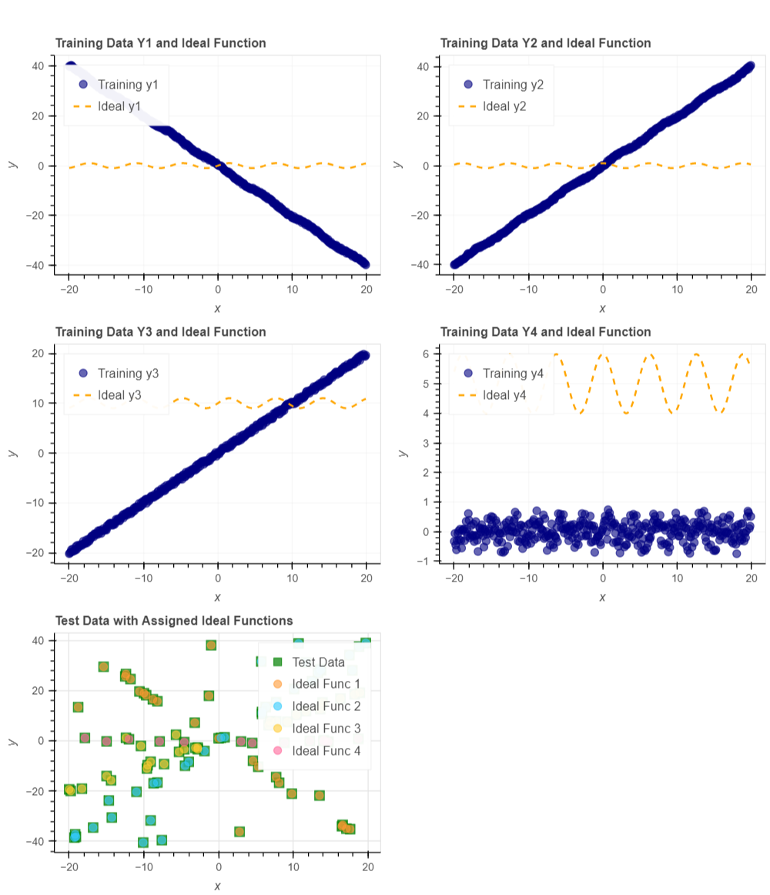

## Conclusion

The presented framework effectively demonstrates a streamlined approach to data processing and visualization in Python. By leveraging the capabilities of pandas, SQLAlchemy, and Bokeh, it provides a powerful tool for researchers and practitioners alike. The modular architecture ensures ease of maintenance and adaptability for future improvements, allowing users to focus on deriving insights from their data rather than the intricacies of implementation. Future work could expand the framework's capabilities by incorporating additional data processing algorithms or enhancing the visualization features to support more complex datasets.

## Additional Notes

While the framework is robust, users are encouraged to conduct thorough testing and validation of the data inputs to ensure optimal functionality. The use of unit tests can greatly enhance the reliability of the data processing pipeline.

## References

1. McKinney, W. (2010). Data Analysis in Python with Pandas. Pandas Documentation.
2. SQLAlchemy Documentation. (n.d.). SQLAlchemy: The Database Toolkit for Python. [SQLAlchemy Documentation](https://www.sqlalchemy.org/).
3. Bokeh Documentation. (n.d.). Bokeh: Interactive Data Visualization in the Browser. Bokeh Documentation.
4. Scikit-learn Documentation. (n.d.). Scikit-learn: Machine Learning in Python. Scikit-learn Documentation.

